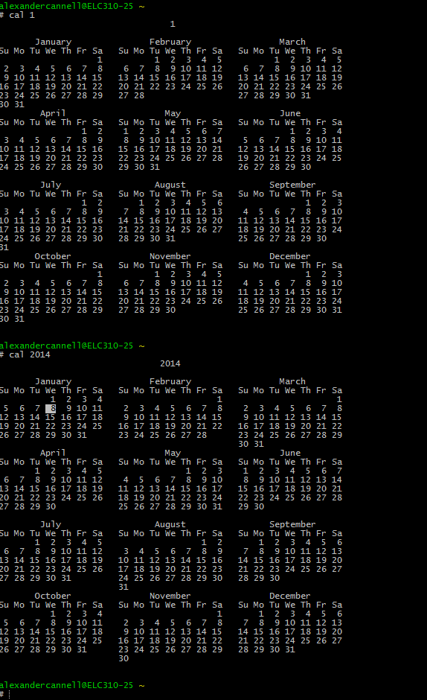

Week 1 -4

Alexander Cannell

You can go all the way to 9999 and back to year 1. September 1752 is weird they dropped from 3 to 13.